Sensory and Fiddle Objects
Dear Parents/Carers,
We have seen a rise across school in children asking for and bringing in sensory toys for the classroom. Fidget and sensory tools are tactile objects that are small enough to be discreetly kept in pockets or hands. They are designed to aid focus, concentration and help prevent distracting behaviour.
In school we are finding that for children who do not need them, these objects are causing distraction and disruption to themselves and others.
When looking online there are now lots of different sensory objects being marketed and they are not what we would use in school as they are essentially a toy and do not aid learning.
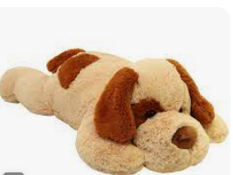
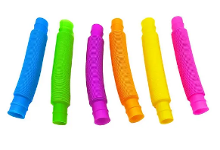
Here are some examples of sensory/fiddle tools that are used in school. This includes a marble, blue tac and weighted teddy.
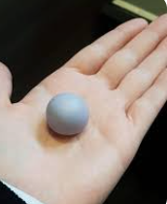
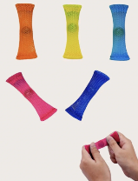

We aim to use small, discreet objects that do not provide any distraction but meet a sensory need for that child.
If your child’s class teacher feels that your child needs a sensory aid in the classroom to help them focus then this will be discussed with myself and/or Mrs Bruce so that the most appropriate aid can be given to support them. This will be to ensure the least possible disruption to them and other children.
If fiddle toys are found in class, they will be taken off the children and given back at the end of the day.

Thank you for your support with this. As always, we are always looking at the best way to support the children and their learning.

Miss Lees
SENCo

