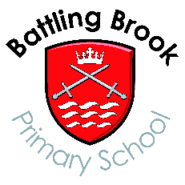

Parent, Teacher & Family Association (PTFA) - School Privacy Notice
SCHOOL are fortunate to have a PTFA that helps support our school with social and fundraising activities.
The PTFA is a separate organisation to the school, so we have to take account of our Data Protection obligations.
The PTFA promotes its activities using social media and contacts with families. As a school, we will share those events using our school media and communication platforms.

What personal data may be shared | We will share  - pupil names, classes  - parent names
What will it be used for? | - To promote upcoming fundraising events in school  - Contact raffle winners if necessary
How long will we keep it? | - Whilst your child remains on roll at school
How will we store it? | - Electronic secured database.  - Any paper based information e.g. raffle tickets/order forms will be stored securely and disposed of after the event.
Will it be shared with others? If so, who? | No
What about your Data Protection rights? | For more information about how data is collected, stored, used and protected, please see our UK GDPR / Data Protection Policy which can be found on our website  https://www.bbrook.leics.sch.uk/page/?title=Privacy+Notices&pid=54  You will find details about your rights and how to access data we hold, and what to do is you are not satisfied or wish to complain.

